In the Binary compensation plan it’s important to know how to balance your team and make placements. Initially you must sponsor one active sale on the left and one active sale on the right in order to be Active yourself. The default is set to the weaker leg, so the placements will begin on your inside leg, but we’ve seen errors in this default and suggest you set the default to the Left or Right to insure proper placement. In order to meet the requirements you’ll need to change the default temporarily or move someone to the other side, and as your team grows, you may need to change the placment to help balance your binary.

How to change your Default Binary Placement:

1. Go to your personal Amega backoffice: http://eamega.com/YOURBANAME (username you chose at signup) and click the Login button. Enter your password and type in the verification code.
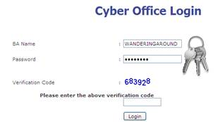

2. Click Personal Profile then click Edit Personal Details:



3. Scroll down to Default Placement and choose either Left or Right (we don’t recommend leaving it on the “Weaker Leg”). To find out what is your weaker, or inside leg, scroll down further to see Upline Placement – if your Upline Position is Left, your weak leg to build would be right. Check your selection, then scroll down and click Update.

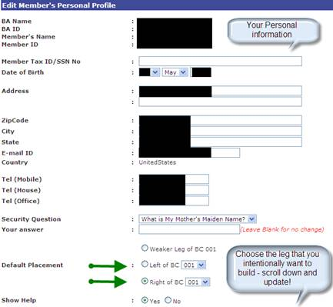

NOTE: You have 24 hours to move someone to the other leg in case of an error:

How to move a BA in your Binary Placement to the other side:

The company policy allows a BA to be moved within 24 hours or until the BA enrolls someone, whichever is sooner.

- On the navigation bar click Utilities, then click Change Placement



2. Enter the BA name of person you want to move, then click Show Placement

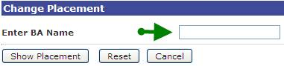

3. Under New Placement Info, make your placement selection, then click Change Placement

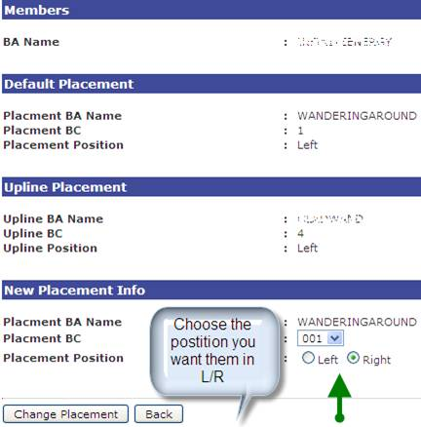

4. To verify the placement change, click Reports, Geneology Tree, then click on your business center, type in the BA name you just moved and click search. You’ll be able to confirm if they are now on the desired side of the sponsor.

