I wanted to introduce you to a zero point energy wand from Asia, that just arrived in the US and Canada in January of this year. I believe this healing tool could be very beneficial to your chiropractic business.

When the wand is directed toward living cells it effects change, and very often within just a few minutes. The energy field restores the energy balance of the cells which speeds healing and can alleviate pain. It helps chronic conditions, soreness, aches, injuries, inflexibility, mental stress, depression, disease… you name it.

Please read this testimonial from Dr Russ Newman in Arizona:

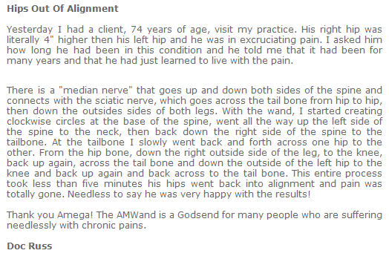
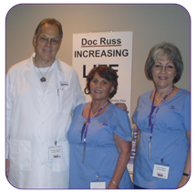

You can listen to a presentation of the wand here: http://www.magicwandreview.com (it's slow loading, but IT WILL GET YOUR ATTENTION) !!

Or dial this recorded number: (951) 262-3156

We are moving into a new age of technology and Self Wellness with Quantum Physics that is much needed in America. The wand is available in 128 countries and Amega has 1.6 million satisfied customers.

Watch this Youtube wand demonstration of 92 year old woman with a frozen shoulder: www.tinyurl.com/yhq26va

Here are some recorded information calls with testimonials: http://getonthecalls.com
Let me know if you have any questions, or would like more information.

