The AMwand is not a "miracle wand", it is an energy source that triggers the “miraculous ability of the body" to move into balance quickly and heal itself. The wand is infused with Amized Fusion Technology (AFT), a proprietary name referring to the harnessing of zero point field energy. When the wand and other Amega products are used, people are experiencing relief from chronic pain, increased flexibility, better sleep, help with anxiety and depression, increased immune response, increased strength, tighter healthier skin, better digestion, relief from joint stiffness, and many more health benefits, many of which happen within just a few minutes. Amega products allow for a better quality of life all around!

Here are some before and after pictures of living cells exposed to AFT:

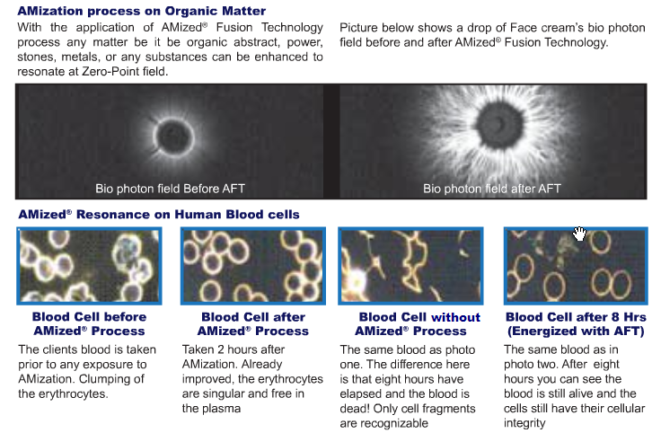
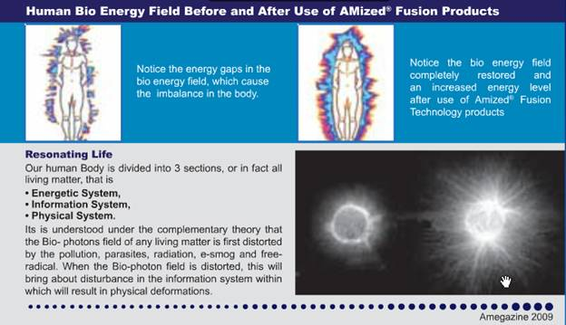

The result of zero point energy on living matter is measurable. The testimonials are also very consistent. AFT products can rapidly energize the human body and electromagnetic field to promote health. The ample supply of vital energy made available to the organism induces a state of homeostasis, or balance. This is what triggers the natural self-healing mechanism necessary for cellular and/or energetic repair and improvement.

To listen to testimonials about the Amega products, please go to http://getonthecalls.com. Each of the calls will have testimonials at the end of the presentation. You can scroll forward about 15-17 minutes into the recordings to hear the testimonial segment. The stories are amazing and randomized from all the different ways the products effect change in the body. Unbeliveable stories from an unbelievable array of “self wellness” products.

Other facts:
Amega Global started in 2004 but did 1.5 years of research and development before launching
Over 550,000 associates (as of December 2009)
Sold in over 135 countries
1.6 million satisfied customers
21 corporate offices in 11 countries

Some of the countries are: Singapore, Malaysia, India, Philippines, China, Japan, Australia, Taiwan, S. Korea, United Arab Emirates, UK, and now Canada and the U.S.
This may be new to North America but the company has been around for 5 1/2 years and the testimonials are undeniably impressive and massive. If you or someone you know would like relief from any human conditions you should consider ordering a wand and some of the other Amega products.

Let me know if you have any questions.

