Don’t delay in getting signed up!
In a Binary Compensation plan you shouldn't wait to get positioned.
By waiting to join my team, you’ll be letting someone else fill the spot above you and you’ll miss
out on all their referrals. The quicker you join, the higher the placement and all of my referrals and
their referrals will land under YOU!
In this example, you waited so Bob got in before you…..



Bob's team grows and David joins. Then David's team grows to 100 - but none of them are
under you. You missed out on hundreds of people and a big loss of income because you
delayed in signing up.

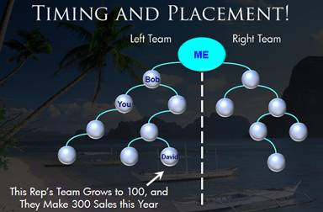

It may not seem important now, but as this product starts to sell itself and you see how
fast the Binary can grow, you’ll be kicking yourself for wasting even 1 day in getting positioned.

My referrals will help build your outside leg! So take advantage of my efforts
and get signed up right away!

Let me know if you have any questions!

