I’ve attached information about Amega’s epigenetic* DNA product, Ega Brine and an explanation of Sulforaphane which is the main nutrient in DNA. Sulforaphane (derived from broccoli sprouts) acts as a switch to turn on the cell’s defense systems.
*(a substance is epigenetic when it’s capable of favourably interacting with cellular DNA).

DNA: Dynamic Nutrition Advantage is a consumable product containing Sulforaphane and fused with zero point field energy just like the wand and the pennant. DNA contains a unique blend of epigenetic superfoods – that switch on more than 200 defense genes to aid natural healing within the body. Mix with water and consume on a daily basis (30 paks per box).

Ega Brine: is a mixture of energized zero point energy water and Himalayan Crystal Salt, which naturally contains 84 trace minerals needed by the body. The Brine helps to restore the body’s PH level back to normal.

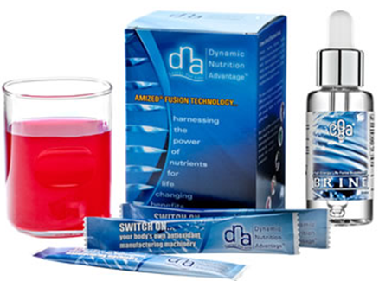

You can set up an your order for the DNA and Brine as an auto-ship to be received every month.

Let me know if you have any questions.

