When you go to my site, http://eamega.com/XXXX and click the sign up now button then follow these steps:

If my ID information doesn’t show up – please type it in:

The sponsor for this Business Associate will be: XXXXX
The Sponsor’s BA ID: XXXXX
1) Choose a username for your site, type your name and Tax ID#, click continue
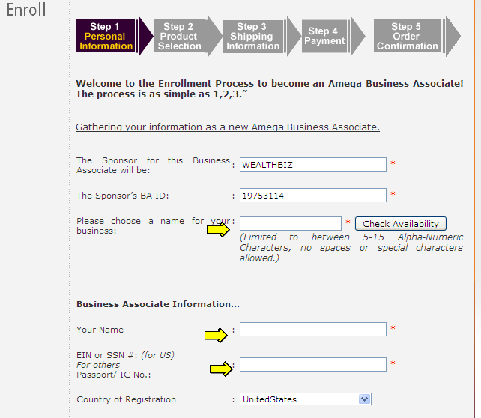
2) Check and agree to Terms and Conditions, click continue
3) The description at the top of the order page shows you the advantage of purchasing more products within your first 21 days. But you have time to upgrade before then, once you learn more about the products and if you decide you want a higher cap on your income. Once I heard about the DNA nutritional product, the Bio-energetic bracelets and the zero point energy Pendant I wanted them all, so I bought them. You can do it now or upgrade before 3 weeks are up. The purchase you make right now can take care of it all. Call me if you need more clarity.

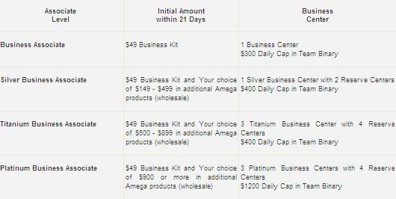

4) Under “Place your Initial Order” you can expand the section called “Bundle Packages” and “Amega AMized Fusion Technology Products” and type in the quantity desired. At the bottom you’ll agree to the $49.00 biz kit and the shipping, then click continue. (The packaged bundles offer a savings over purchasing individually).
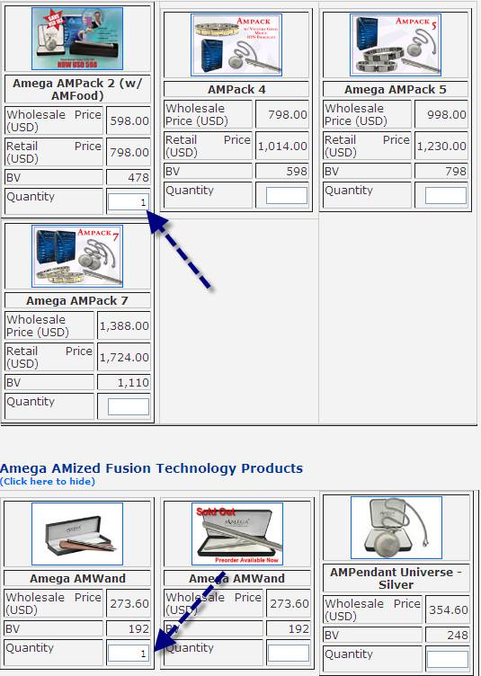
5) Click “continue” (this is an example of a Bundle Pack and additional wand that meets the requirement of Platinum)
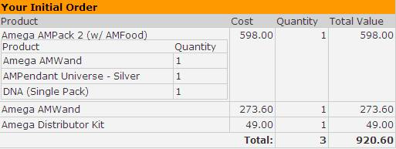
7) click ‘No, I want to checkout’
8) Next you can set up a monthly Auto Ship (that will start the following month). Check the box and add the DNA product (this will qualify you to earn commissions*). This is a zero point energy product that switches on the cell’s defense genes. Check the box, then type a “1” next to the DNA product and click “No, I want to Checkout”.
* If you are going to refer others, you need to have a personal volume of 60 (PV 60) every month to be qualified to earn commissions. The DNA product (PV 75) will satisfy that requirement and you will not have to worry about your qualifications in your 2nd month.
9) Fill in your details along with your billing address (for your credit card), then under “Delivery week for auto-ship”, change it to the 4th week. This will give you 7 to 8 weeks before your first Auto Ship product will be charged and sent.
10) Confirm your order and check the Auto Ship details, then click continue.

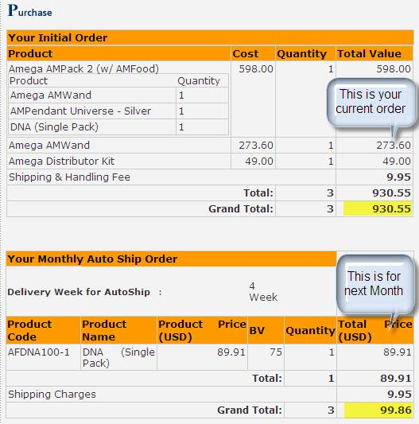

11) Add your credit card and click Next. Occasionally certain credit cards have trouble – the easiest way to solve that issue is to call me.

Please let me know if you have any questions.

