When you go to my site, http://eamega.com/XXXX click the sign up now button then follow these steps:

If my ID information doesn’t show up – please type it in:

The sponsor for this Business Associate will be: XXXX
The Sponsor’s BA ID: XXXX
- Choose a username for your site, type your name and Tax ID#, click continue
- Check and agree to Terms and Conditions, click continue
- The description at the top of the order page shows you the advantage of purchasing more products within your first 21 days. But you have time to upgrade before then, once you learn more about the products and if you decide you want a higher cap on your income. Once I heard about the DNA nutritional product and the Bio-energetic bracelets and the zero point energy pendant I wanted them all, so I will be upgrading before my 3 weeks are up. For now, just skip to the next part.

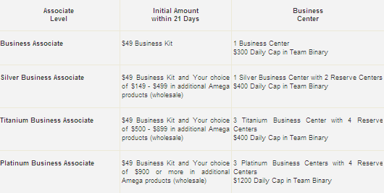

- Under “Place your Initial Order” you can expand the section called “Amega AMized Fusion Technology Products” and type a “1” for the wand @ $273.60. At the bottom you’ll agree to the $49.00 biz kit and the shipping, then click continue. (You may decide you want to purchase some of the packages with the other products too, but you can always upgrade later).
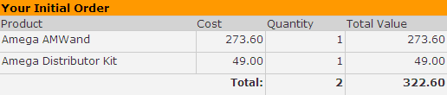
- click ‘No, I want to checkout’
- Now you can set up a monthly Auto Ship (that will start the following month) so I checked the box and added the DNA product, after hearing how amazing it was. Check the box, type a “1” next to the DNA then click “No, I want to Checkout”.
Note: If you are going to refer others, you need to have a personal volume of 60 every month to be qualified to earn commissions. The DNA product (PV 75) will satisfy that requirement and you will not have to worry about your qualifications in your 2nd month.
- Fill in your details along with your billing address (for your credit card), then the change “Delivery week for autoship” to the 4th week. This will give you a month before your first Auto Ship product will be charged and sent.
- Confirm your order and check the Auto Ship details, click continue.

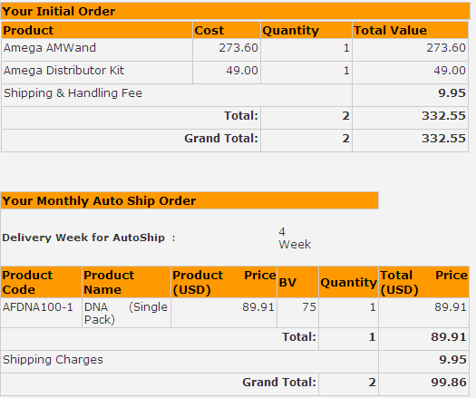

- Add your credit card and click Next.

If you have any questions, just email or call.

