If you were looking for a miracle to help your body in any way or for any reason, it's here!

This wand from Asia was just brought to the U.S. and Canada in January and is fused with zero point energy. When the wand is directed toward living cells it effects change, and very often within just a few minutes. The energy field reminds the body of its own miraculous ability to heal itself and move into balance quickly. This is about relief from chronic pain, soreness, aches, injuries, inflexibility, mental stress, depression, disease… you name it. People all over the globe are getting healed.
That's why I'm asking you to listen to this recording. I only listened a few minutes before I called my friend and ordered a wand.

WOW..... how soon will the mail get here? Are you kidding me? Amazing!

Listen to this: http://www.magicwandreview.com (it's slow to load, but worth a few minutes of your time)!

We are moving into a new age of technology and wellness with Quantum Physics and zero point energy that will blow you away. The wand is in 135 countries and people all over the globe are experiening a better quality of life.

The Self Wellness Revolution is at hand, and I sincerely hope you'll take a few minutes out of your busy day to see what we have available to us.
I look forward to hearing back from you after you listen. You can also call me for my own personal testimony with the wand.

Watch this youtube video of a 92 year old getting wanded that has a frozen shoulder:
www.tinyurl.com/yhq26va

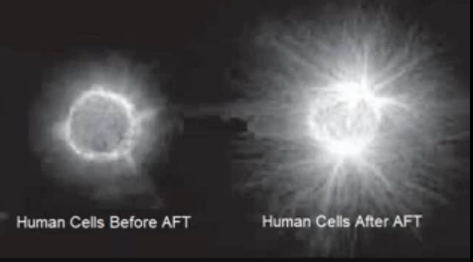
Information calls here: http://getonthecalls.com

Live Calls -
Monday - Tuesday – Wednesday - Thursday
218-862-1300 Pin: 886161#
PST | MST | CST | EST
12:00 PM | 1:00 PM | 2:00 PM | 3:00 PM
6:00 PM | 7:00 PM | 8:00 PM | 9:00 PM

